Ellis Wheeler Tracer Wire Verbiage

Open Trench/Open Cut

Tracer wire for open-cut installation shall be a 12 AWG solid, PRO-TRACE® HF-CCS PE30. Conductor shall be annealed, 21% IACS, copper-clad steel, utilizing AISI 1006 low carbon steel core with minimum break load of 282 lbs. or 55,000 psi (required to meet break load, flexibility, and ASTM B910). Conductor shall be extruded with a 30 mil, high density, high molecular weight polyethylene (HMW-HDPE) pursuant to ASTM D1248. Tracer wire shall be rated for direct burial use at 30 volts and RoHS compliant. Tracer wire shall be PRO-TRACE® HF-CCS PE30 as manufactured by Pro-Line Safety Products and distributed by Ellis Wheeler.

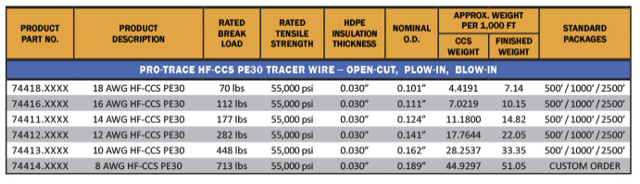

Directional Drilling

Tracer wire for directional boring installation shall be a 12 AWG solid, PRO-TRACE HDD-CCS PE45. Conductor shall be hard-drawn, 21% IACS, copper-clad steel, utilizing AISI 1055 high carbon steel core with minimum break load of 1,330 lbs. or 260,000 psi (required to meet break load). Conductor shall be extruded with a 45 mil, high density, high molecular weight polyethylene (HMW-HDPE) pursuant to ASTM D1248. Tracer wire shall be rated for direct burial use at 30 volts and RoHS compliant. Tracer wire shall be PRO-TRACE HDD-CCS PE45 as manufactured by Pro-Line Safety Products and distributed by Ellis Wheeler.

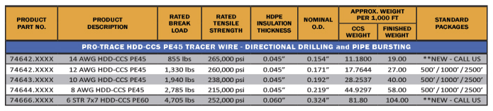

The highlighted portions will have to be switched out if you change the gauge size.

For example, if you switched the open cut spec to a 14 AWG you would have a break load of 177lbs.

The break loads and PSI are listed on the spec sheets.

